Use structured reasoning / step-by-step prompting to generate:
Test Strategy Document:
Context: Act as a Test Manager for Manual testing
Instruction:
[Mandatory]Design Test Strategy Document for Core Banking Fund Transfer
[Mandatory]Ask 5 MCQ to understand the scope
[Critical]Once i answer the questions, add necessary details for strategy document and share the document in word format
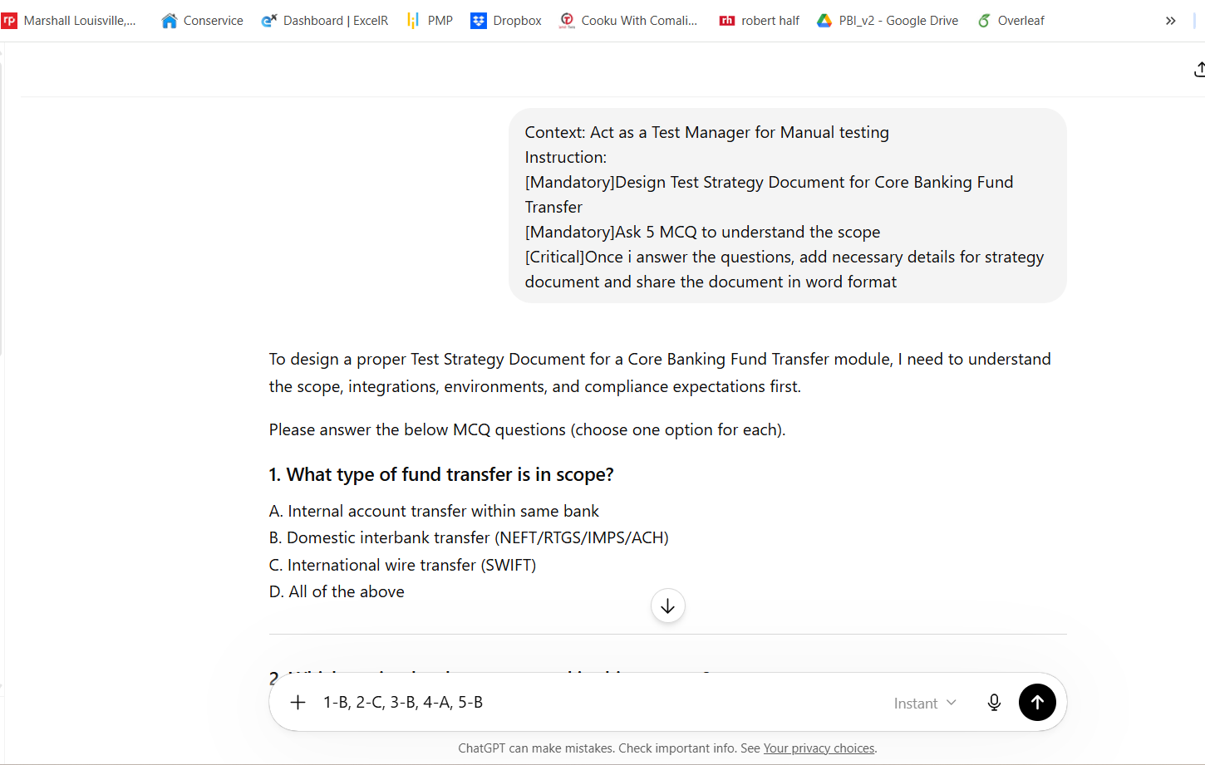

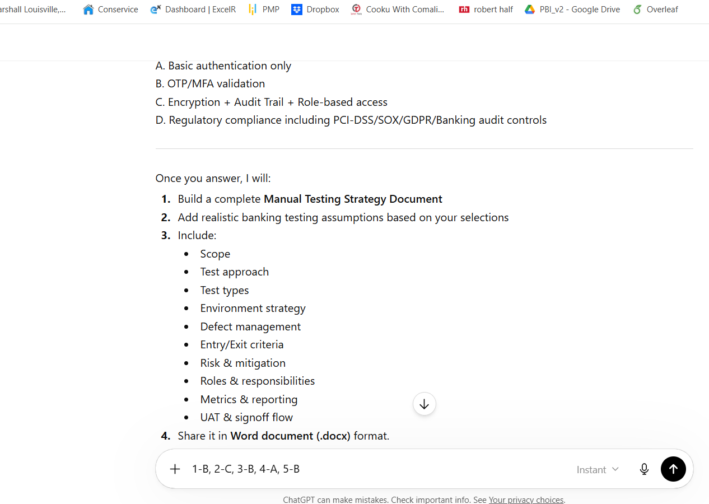
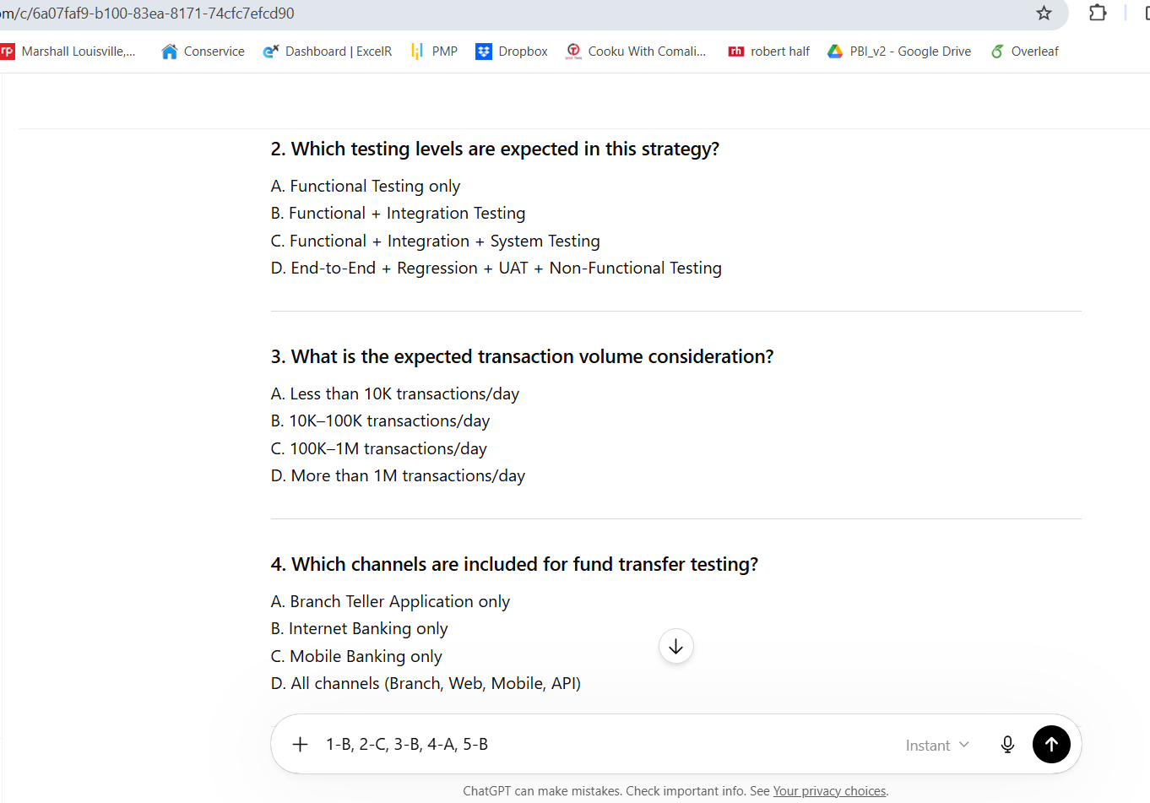
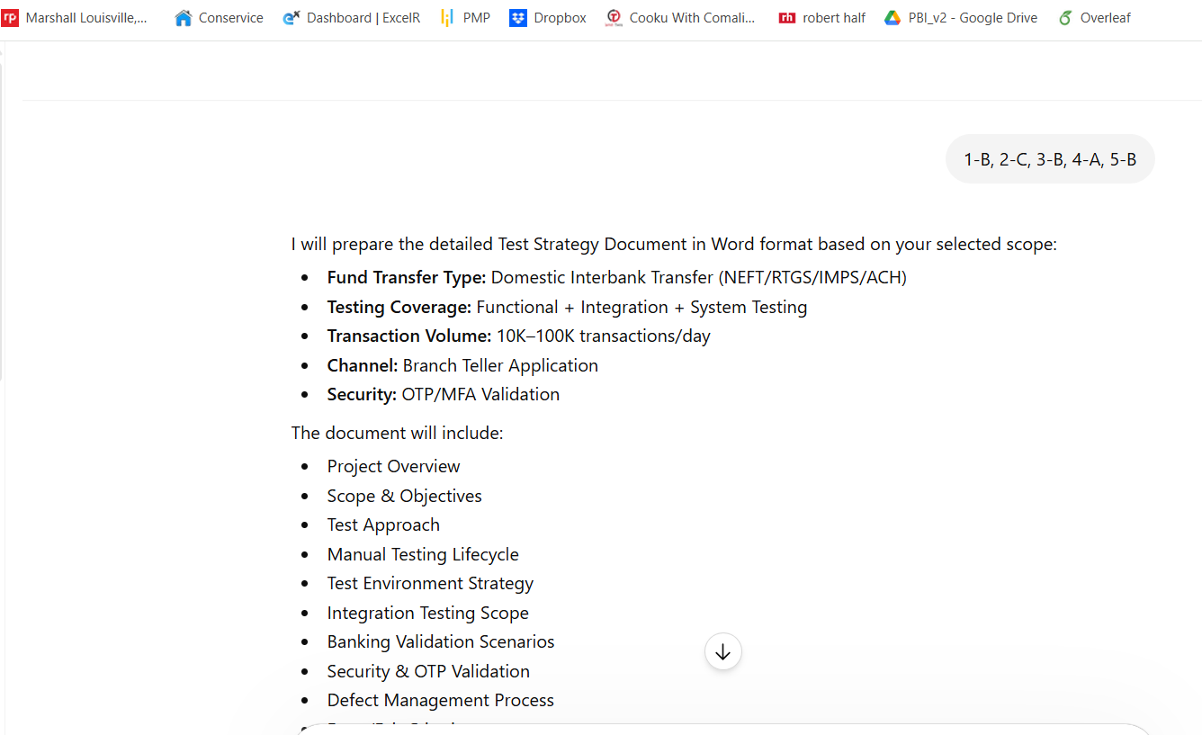
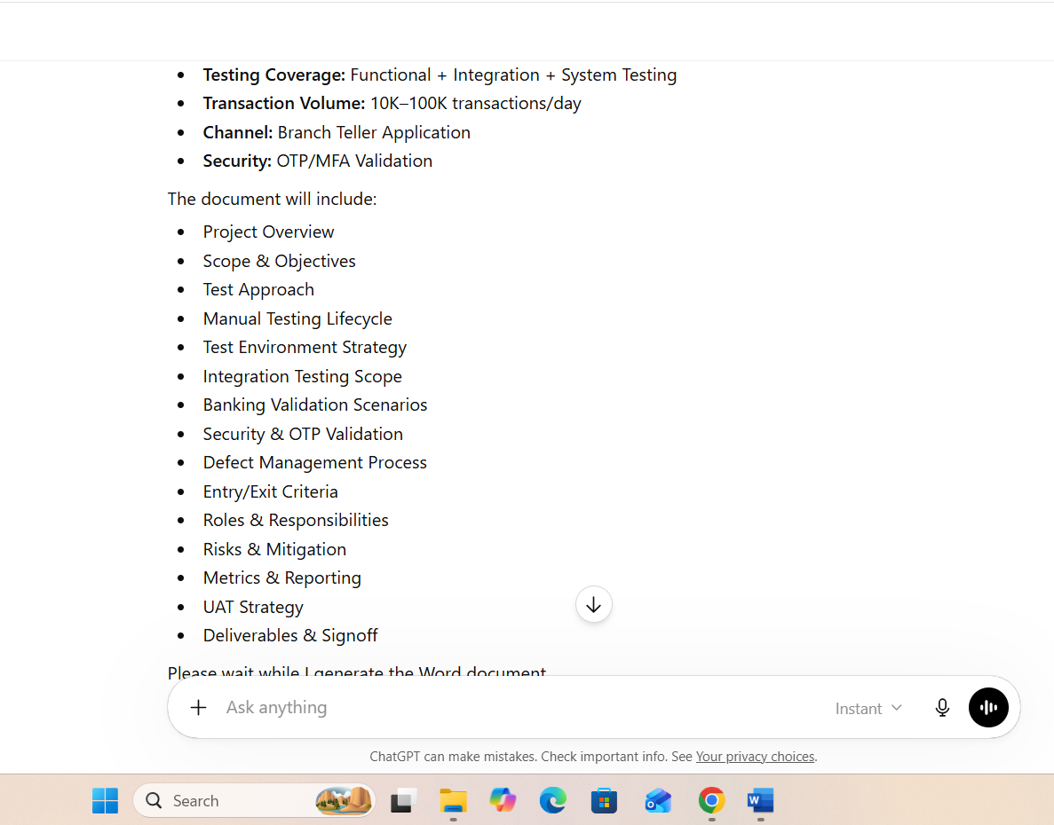
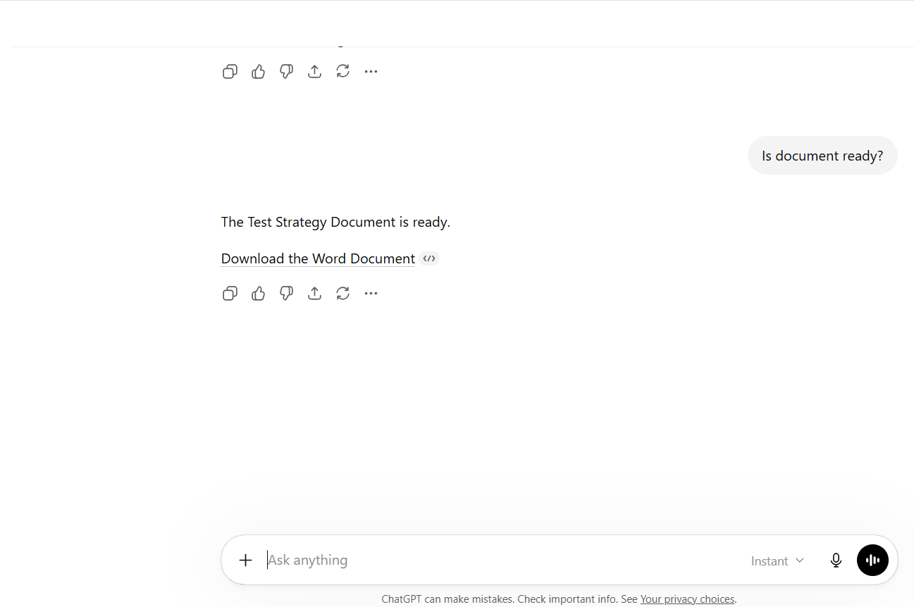

A Test strategy document is generated.

